Task 1

INCLUDE Irvine32.inc

.data

.code

main PROC

mov ebx,0

mov eax,ebx

call writedec

call crlf

mov edx,1

mov eax,edx

call writedec

call crlf

mov ecx,10

li:

mov eax,ebx

add eax,edx

call writedec

call crlf

mov ebx,edx

mov edx,eax

loop li

exit

main ENDP

END main

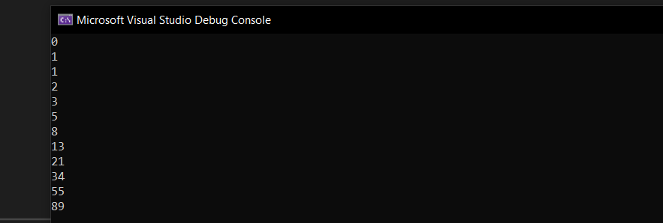

Task 2

INCLUDE Irvine32.inc

.data

.code

main PROC

mov ecx,4

mov eax,1

mov ebx,4

outerloop:

mov ecx,ebx

innerloop:

call writedec

loop innerloop

call crlf

cmp ebx,1

je endl

dec ebx

jmp outerloop

endl:

exit

main ENDP

END main

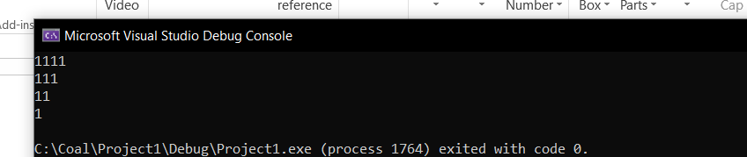

INCLUDE Irvine32.inc

.data

.code

main PROC

;mov ecx,4

mov eax,4

mov ebx,4

outerloop:

mov ecx,ebx

mov eax,4

innerloop:

call writedec

dec eax

loop innerloop

call crlf

cmp ebx,1

je endl

dec ebx

jmp outerloop

endl:

exit

main ENDP

END main

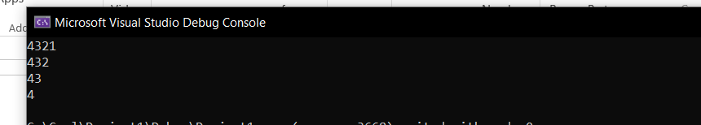

INCLUDE Irvine32.inc

.data

.code

main PROC

;mov ecx,4

;mov eax,1

mov ebx,4

outerloop:

mov ecx,ebx

mov eax,1

innerloop:

call writedec

inc eax

loop innerloop

call crlf

cmp ebx,1

je endl

dec ebx

jmp outerloop

endl:

exit

main ENDP

END main

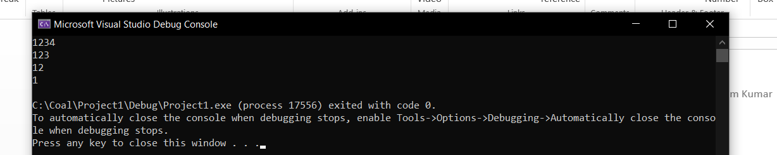

Task 4

INCLUDE Irvine32.inc

.data

scr byte "Hello World",0

target byte 20 dup(?)

.code

main PROC

mov ecx,lengthof scr

mov edi, offset scr

mov esi, offset target

li:

mov al,[edi]

mov [esi],al

add edi,1

add esi,1

loop li

mov edx, offset target

call writestring

exit

main ENDP

END main

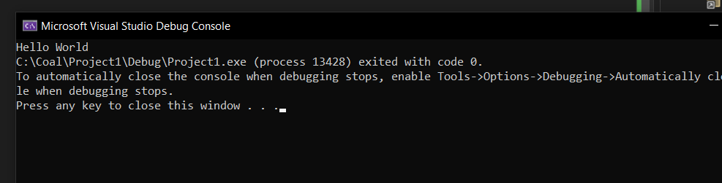

Task 5

INCLUDE Irvine32.inc

.data

arr DWORD 5,4,3,2,1

len = ($ - arr) / 4

.code

main PROC

jmp bubble

bubble:

call Crlf

mov esi, OFFSET arr

mov ecx, len

dec ecx

jz endBubble

outerLoop:

mov edi, OFFSET arr ; Reset edi to the beginning of the array

mov ebx, ecx ; Set ebx to the current iteration of the outer loop

innerLoop:

mov eax, [edi]

mov edx, [edi + 4]

cmp eax, edx

jle noSwap

; If eax > edx, swap elements

xchg eax, edx

mov [edi], eax

mov [edi + 4], edx

noSwap:

add edi, 4

dec ebx

jnz innerLoop

loop outerLoop

endBubble:

mov esi, OFFSET arr

mov ecx, len

printArray:

mov eax, [esi]

call WriteInt

add esi, 4

loop printArray

jmp en

en:

exit

main ENDP

END main

